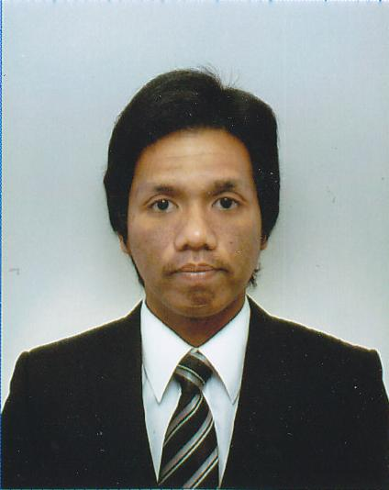**HAIRUL AZIZAN BIN MOHAMED SHAFFRIL**

**Current Address :** 101 Takahashi Haitsu,Bunkyou 3-20-16, Fukui-shi, Fukui-ken,

910-0017, Japan.

**Permanent Address :** Syarikat Tenaga Muda, Batu 12 1/2 Jalan Cheras,

43000 Kajang, Selangor.

**Email :** hairulazizan@gmail.com

**Mobile No. :** +6019-3923066 (Malaysia)

+81(0)80-4224-1278 (Japan)

**PERSONAL DETAILS**

**Date of Birth :** 7 August 1989

**Nationality :** Malaysia

**Interests :** Sports, movies, food, travelling

**Marital Status :** Single

**Health :** Excellent

**CAREER OBJECTIVE**

To build a long term career in mechanical engineering, with prominence on product Research and Development in order to enhance my professional skills and empower with the cutting edge of the technologies.

**EDUCATION**

**2012 – 2014** University of Fukui Japan

**Bachelor in Mechanical Engineering**

**FINAL YEAR PROJECT Title :** Development of control educational material utilizing TK400SH

**Description :** Propose an educational material MCORE-IP which is to develop program that can operate the TK400SH microcomputer using the Arduino toolbox and thus programming in C language is not necessary anymore

**2009-2012** Fukui National College of Technology

Diploma in Mechanical Engineering

**FINAL YEAR PROJECT Title :** Production of yarn processing using false twist double-stack disc friction

**(DIPLOMA) Description :** Double-stack disc friction units were used to produce good, high yield yarn-like wool

**2007 – 2009**  Preparatory Center for Technical Studies to Japan

Monbukagakusho Examination Japan

**2005 – 2006** Gombak Integrated Boarding School

SPM 8A (7 A1, 1 A2)

**WORKING EXPERIENCE**

**August 2010** **Toyohashi University of Technology (Intern)**

Data analysis and measurement of driving behavior

* Obtaining data from experiment simulated by software that has similar course to the city’s road environment using Driving Simulator.

Face angle measurement using monocular camera

* Face image will be acquired by securing the face with the measuring instrument and rotating the camera, and the acquired image will be processed by factorizing program which will in turn calculate the data of the face’s angle.

**AFFILIATIONS / ACTIVITIES**

**UNIVERSITY OF FUKUI JAPAN**

**2012-Present** President of Malaysian student society University of Fukui

Committee Member of Futsal Club

**2013** Captain offootball teamfor Touhoku Football Tournament under MSAJ (Winner)

**2012** Chugoku Football Tournament under MSAJ (Winner)

**FUKUI NATIONAL COLLEGE OF TECHNOLOGY**

**2011** Vice president of Malaysian Student’s Association in Japan, Hokuriku

Captain offootball teamfor Hokuriku Football Tournament under MSAJ (Winner)

Captain offootball teamfor Toukai Football Tournament under MSAJ (Winner)

Captain offootball teamfor IPIJ Champion’s League Football Tournament (Winner)

**2010** Participant of Robot Competition

**PREPARATORY CENTER FOR TECHNICAL STUDIES TO JAPAN**

**2007 – 2009** President for student society

**2008** Football Tournament Inter Japan Preparatory Center in Malaysia (1st runner up)

Participant of Futsal Tournament UTM Jalan Semarak

**GOMBAK INTEGRATED BOARDING SCHOOL**

**2005 – 2006** Captain for sport house

Engineering Drawing and Engineering Technology Competition, State level (2nd runner up)

Captain of football team for Football Tournament, District level (2nd runner up)

Participant of Volleyball Tournament, District level

Participant of Badminton Tournament, District level

**SKILLS ACQUIRED**

**Computing :** Microsoft Office (Excel, Power Point, Word, Visio), Scilab, Maxima, C++, AutoCAD

**Laboratory :** General laboratory handling, laboratory safety handling

**Communication :** Presentation skill, lab report writing, logbook writing

**Languages :** Malay, English, Japanese

**Qualification :** **Japanese Language Proficiency Test :** Level 3

**Test of English for International Communication (TOEIC) :** 750/990

**Test in Practical English Proficiency :** Grade 2

**Others :** Project management, time management, priority management

**REFEREES**

**Mr.Ryoji Kawatani**

Associate Professor

University of Fukui Japan

Faculty of Mechanical Engineering

3-9-1 Bunkyou-shi Fukui-shi

910-8507 Fukui Japan

**Email :** r_kawa@u-fukui.ac.jp

**Mr. Naoto Kaneda**

Assistant Lecturer

Fukui National College of Technology

Faculty of Mechanical Engineering

Geshi-cho Sabae-shi

916-0064 Fukui Japan

**Email :** kaneda@fukui-nct.ac.jp